SFML Set up Guide

(Note: This is for Visual Studio 2012)

1. Go to <http://www.sfml-dev.org/download/sfml/2.1/> and download the **32 bit Visual C++ 11** file.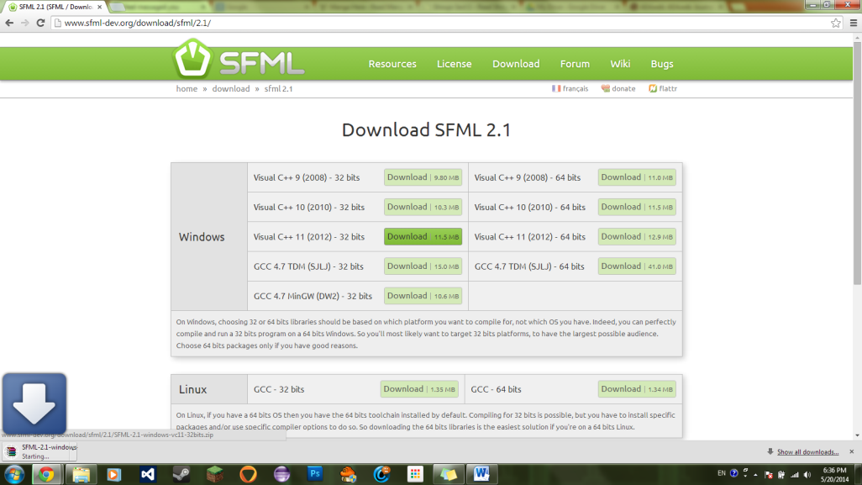
2. Drag the file into the directory in which you wish to save sfml assets. In this case, the location that I will be using is **G:\sfml**
3. **Extract the .zip file** that you just downloaded in the directory that you created. You should have something like this: 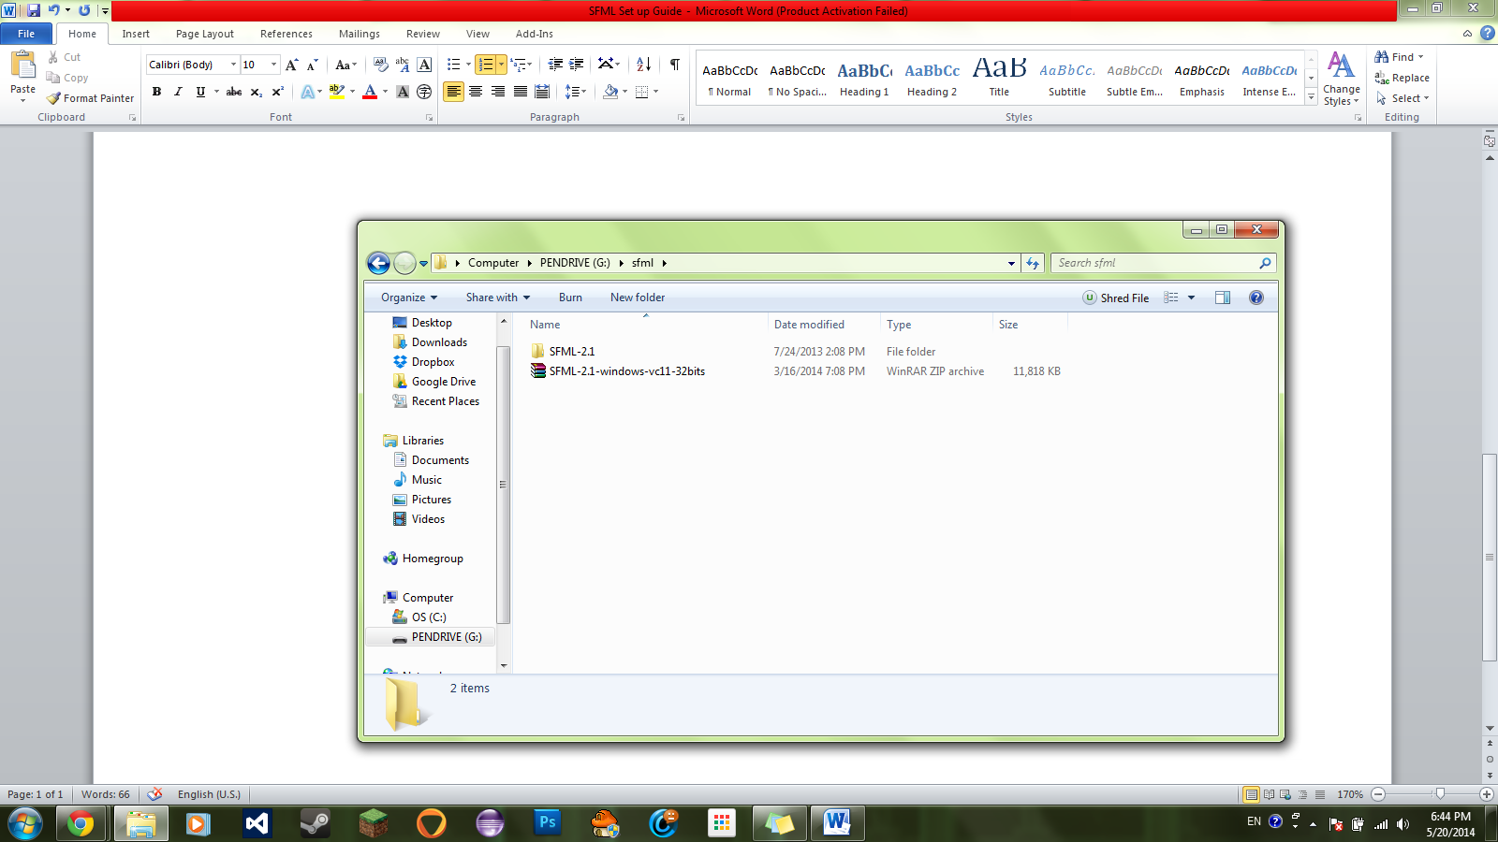
4. After you have extracted the file, open up Visual Studio 2012. Make a new project and call it what you want. **Make sure you create an empty project**. 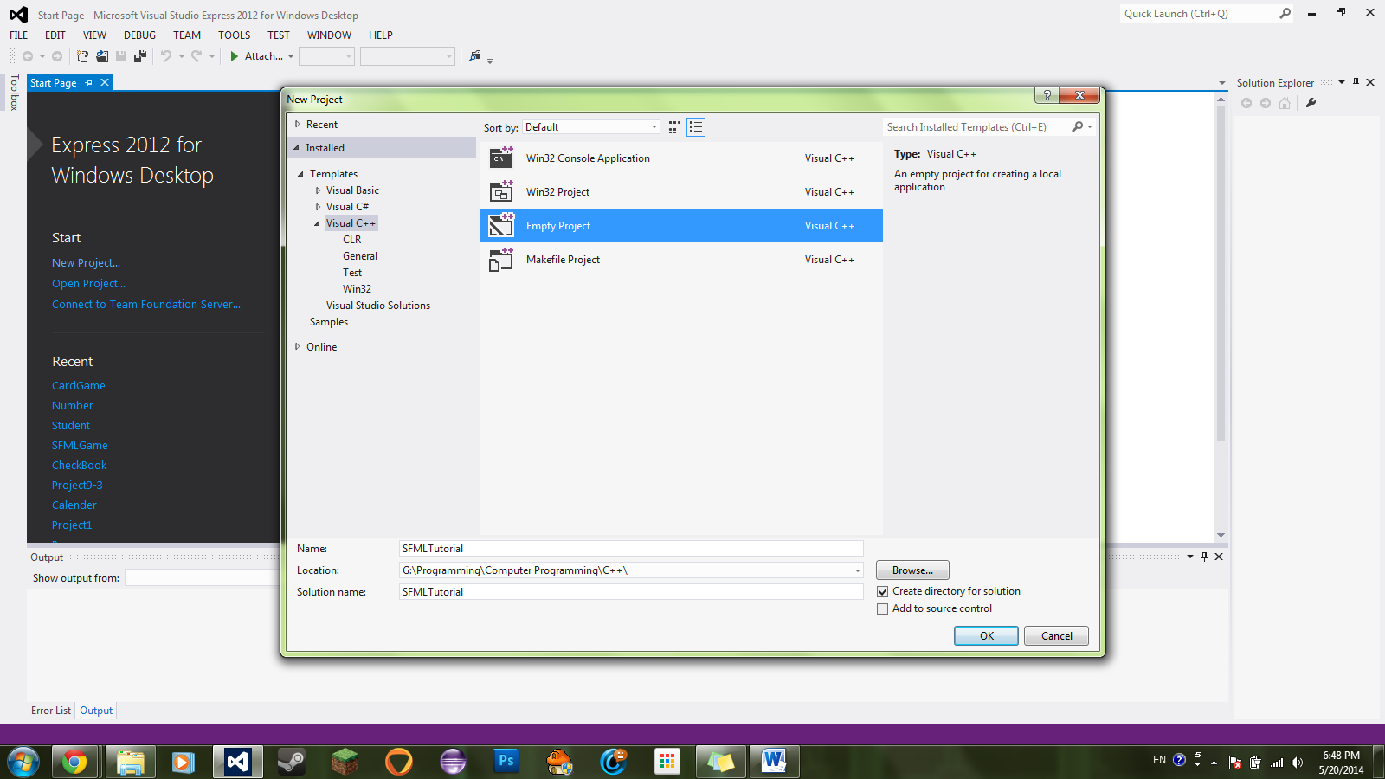

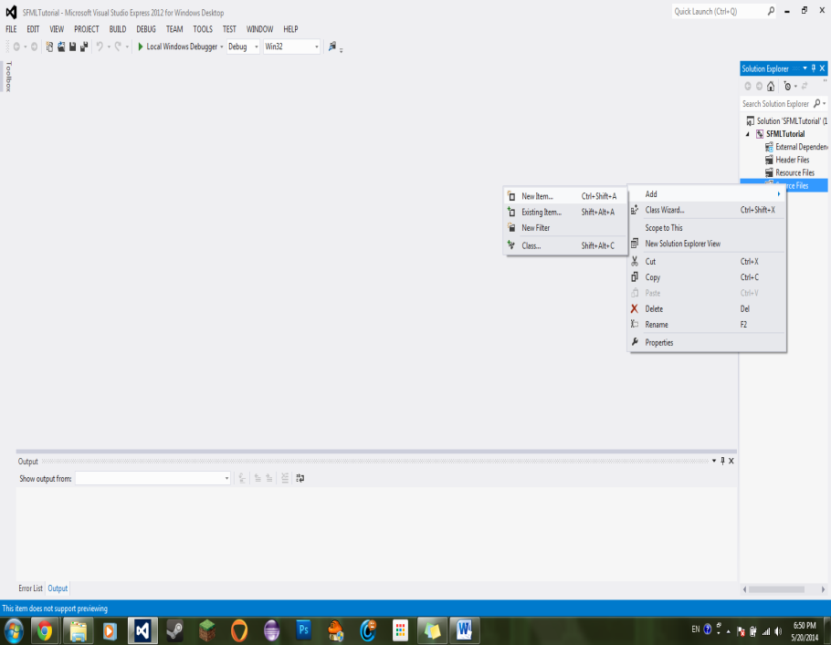

1. Once you have the project created, **create a .cpp file** for your main

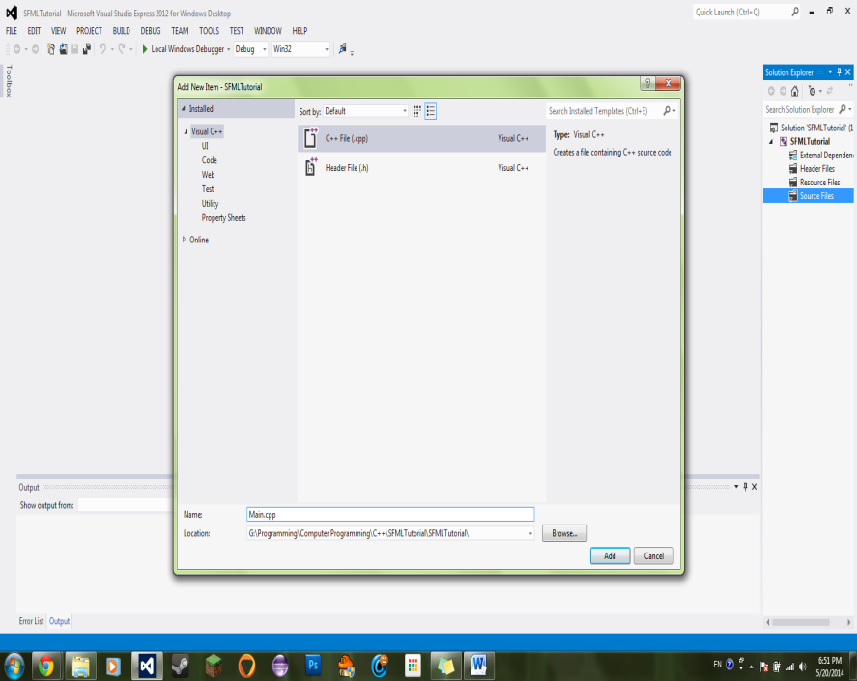

1. **Paste this code into your main file** (If you get errors, that’s fine):

**#include <SFML/Graphics.hpp>**

**int** main()

{

sf::RenderWindow window(sf::VideoMode(200, 200), "SFML works!");

sf::CircleShape shape(100.f);

shape.setFillColor(sf::Color::Green);

**while** (window.isOpen())

{

sf::Event event;

**while** (window.pollEvent(event))

{

**if** (event.type == sf::Event::Closed)

window.close();

}

window.clear();

window.draw(shape);

window.display();

}

**return** 0;

}

1. Next begins the bulk of the setup. On the top bar of Visual Studio, **click the DEBUG header**. Scroll to the bottom and **click Properties**. 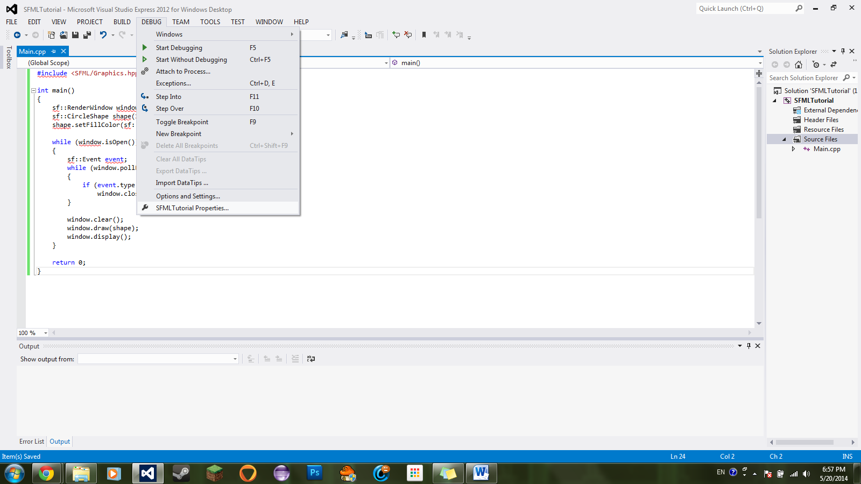
2. Once are inside Properties, **change the Configuration** from **Active(Debug)** to **All Configurations**. 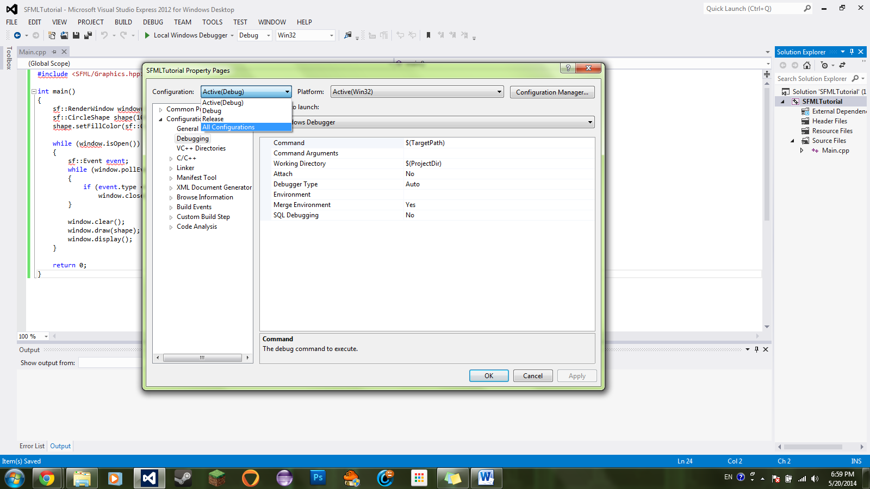
3. Now **click on C/C++**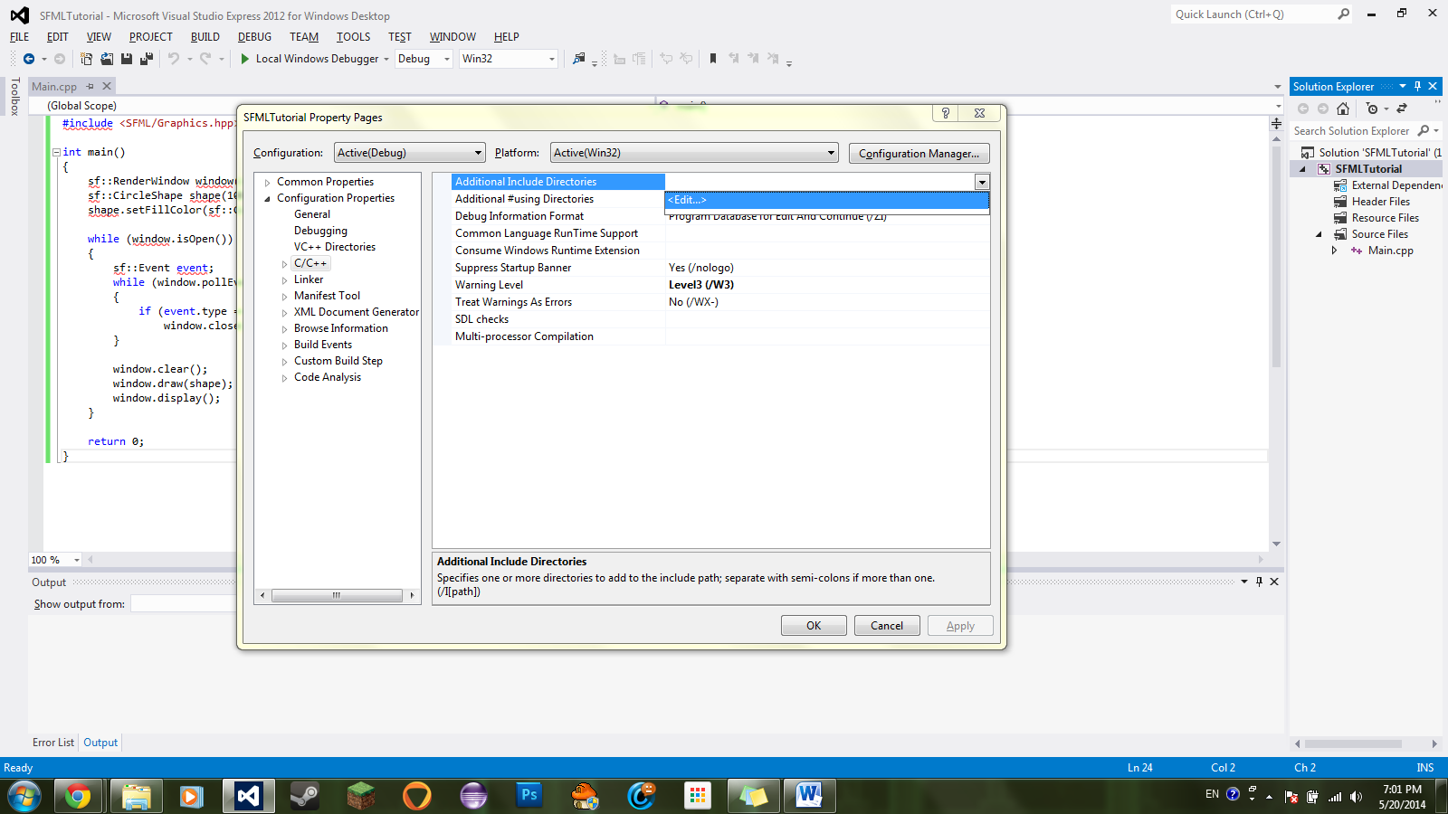
4. Inside, **click on the dropdown box under Additional Include Directories**. **Click <Edit…>**
5. Once inside the edit screen, **click the folder button**, and then the **…** button that showed up. Now **navigate to** where you stored **your SFML-2.1 folder** (**G:\sfml\SFML-2.1**)

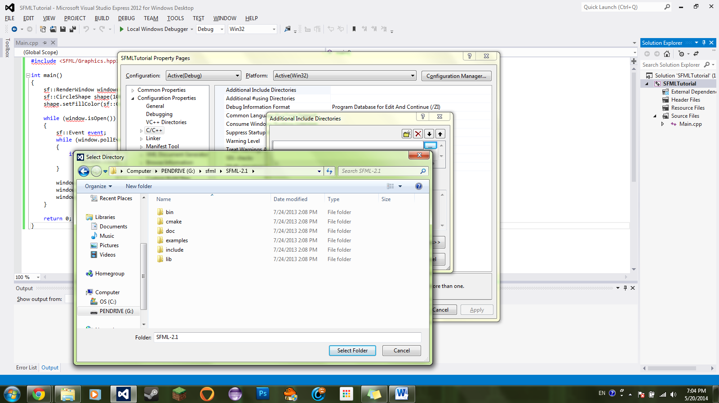

1. Go into the **include** folder and click **Select Folder** (do not click any further than the include folder).
2. Now click **Linker**. Navigate to where it says “**Additional Library Directories**” and click on the dropdown arrow and then click **<Edit…>**
3. Like with the last linking you did, navigate to where you stored your sfml folder. This time though, instead of clicking the include folder, choose the **lib** folder (**E:\sfml\SFML-2.1\lib**)

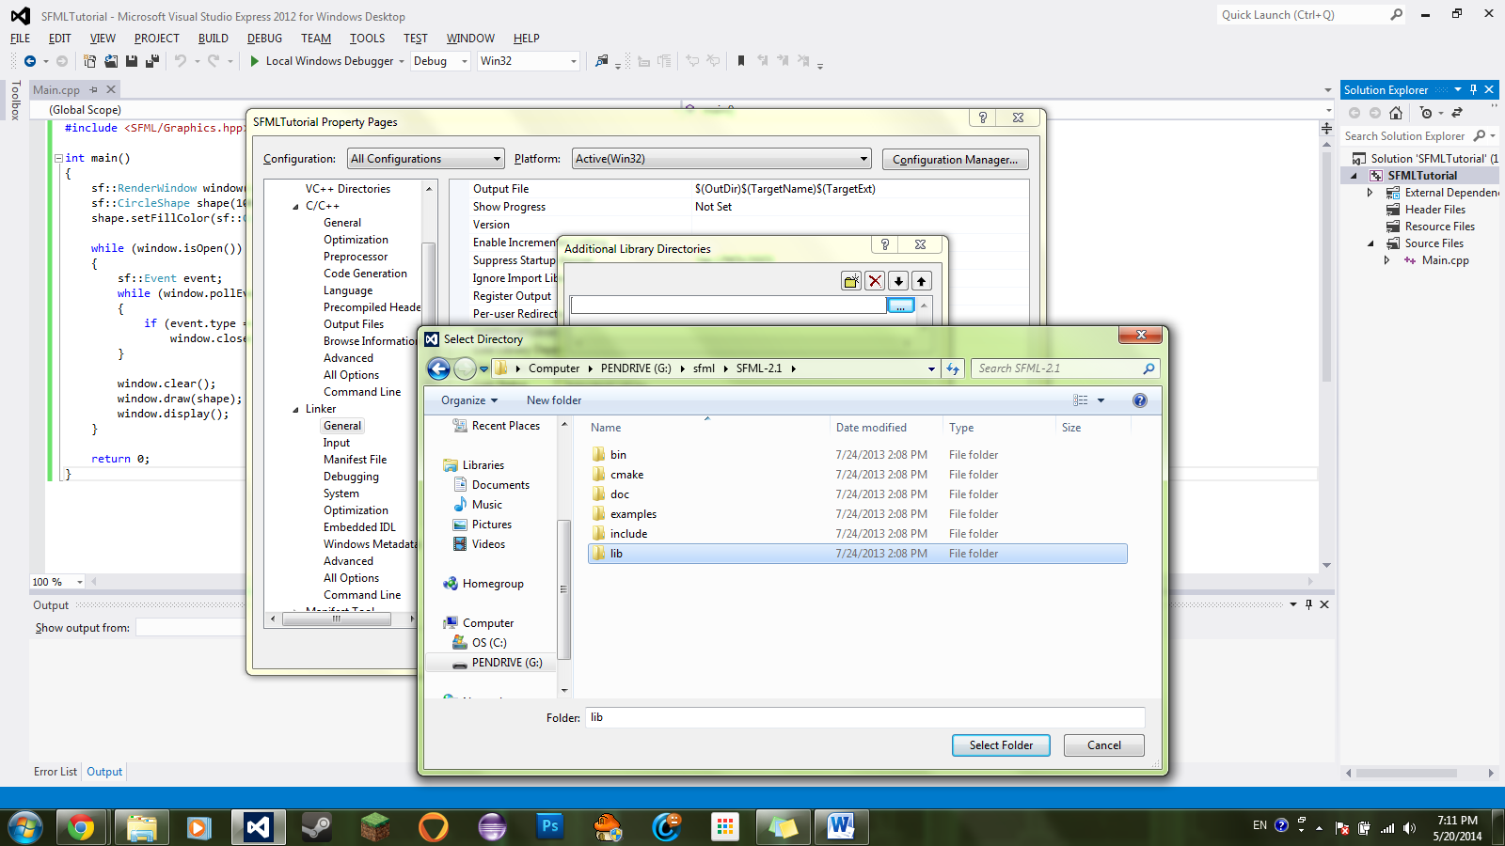

1. Now go to the top right and change where it says “All Configurations” to **Active(Debug)**. If it asks you to save, click yes.
2. Now go into **Linker 🡪 Input**
3. Where it says **Additional Dependencies**, click the dropdown arrow and click **<Edit…>**. A window with an empty textbox should appear. 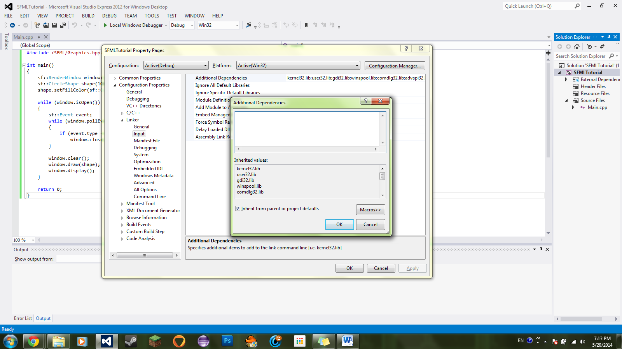
4. Now type in this into the textbox (Make sure you go to another line with each entry):

sfml-graphics-d.lib

sfml-main-d.lib

sfml-system-d.lib

sfml-window-d.lib

sfml-network-d.lib

sfml-audio-d.lib

1. Hit OK, save changes and exit the Property window
2. Now run the program. If you get an error saying that a .dll is missing but a console window appears, you have set things up properly.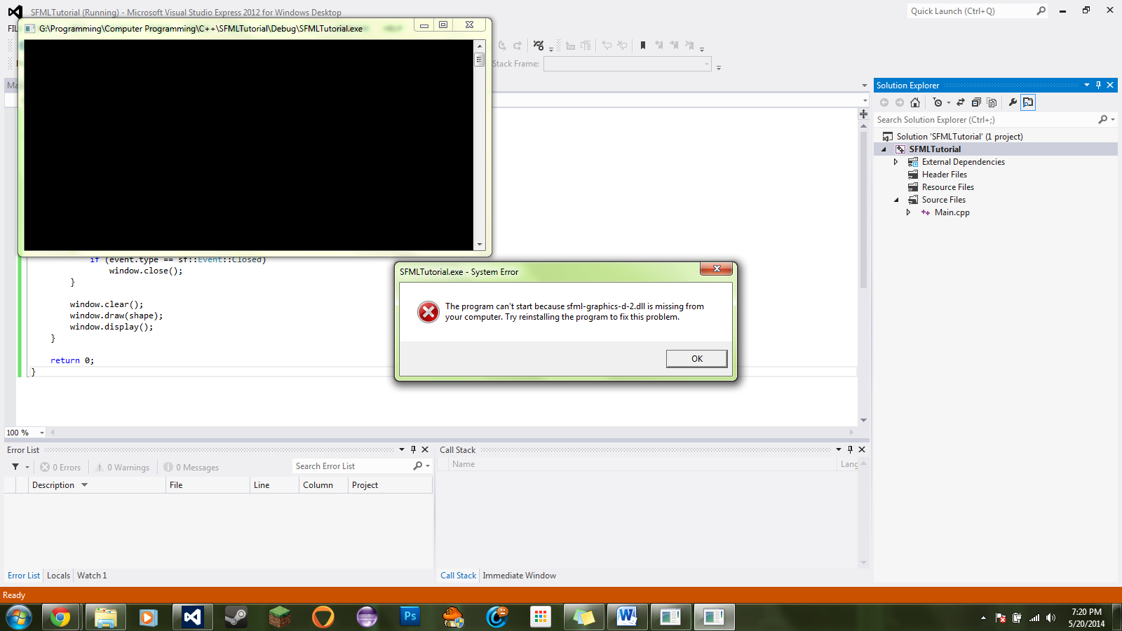
3. Now open up the folder directory of where your SFML folder is located. Go inside the **bin** folder (**G:\sfml\SFML-2.1\bin**). There should be lots of .dll files.

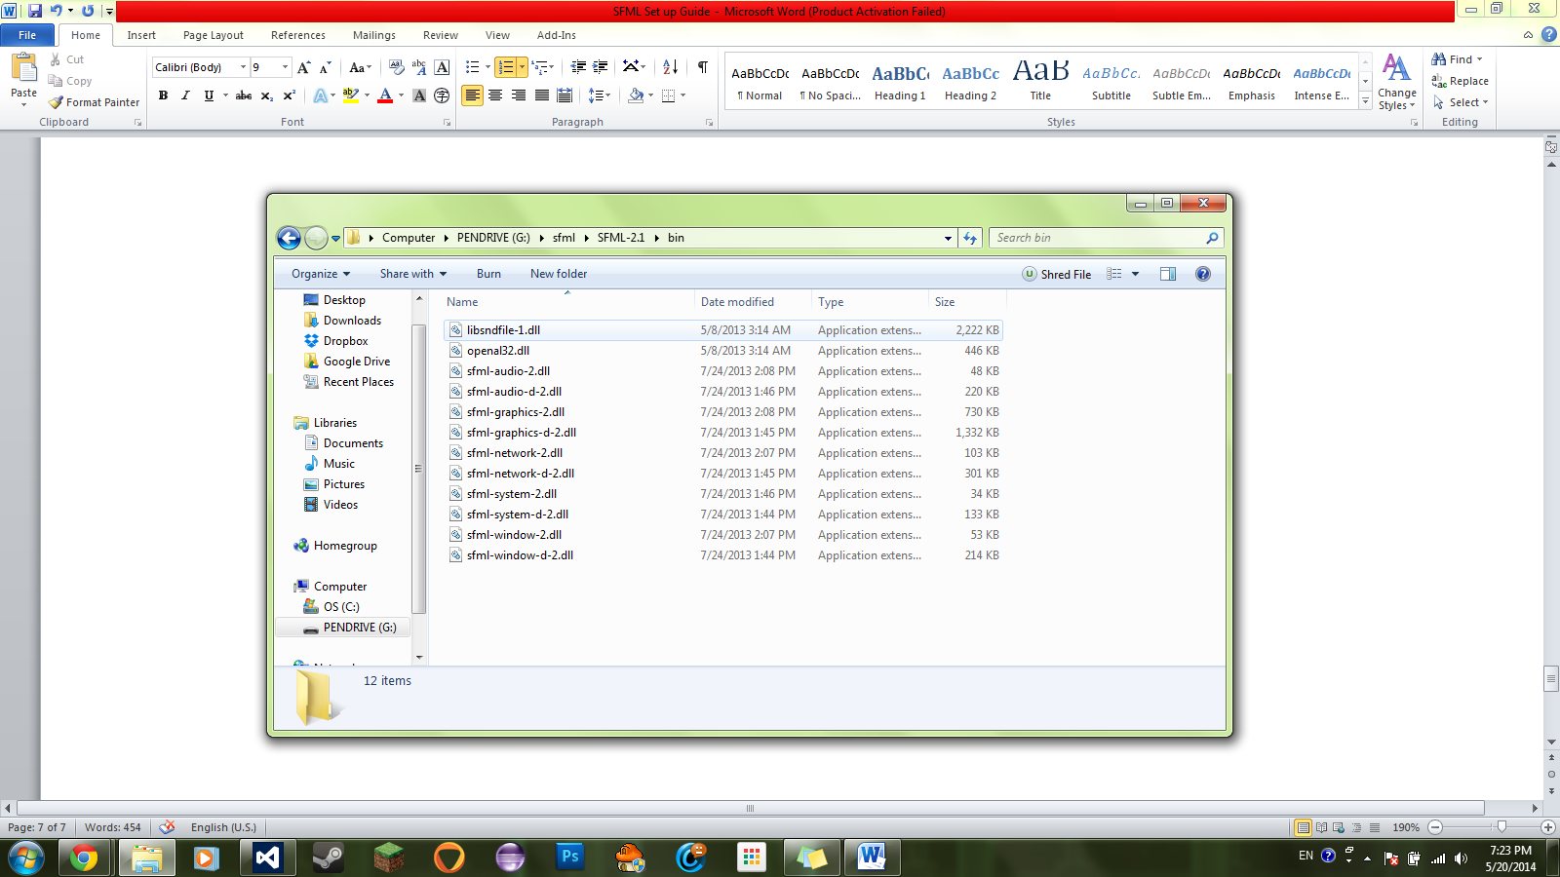

1. **Copy** all the files.
2. Now open up a new folder directory and navigate to where you stored your Visual Studio Project. Once you located your Project folder, navigate into the **Debug** **folder**. In there should be your .exe file. 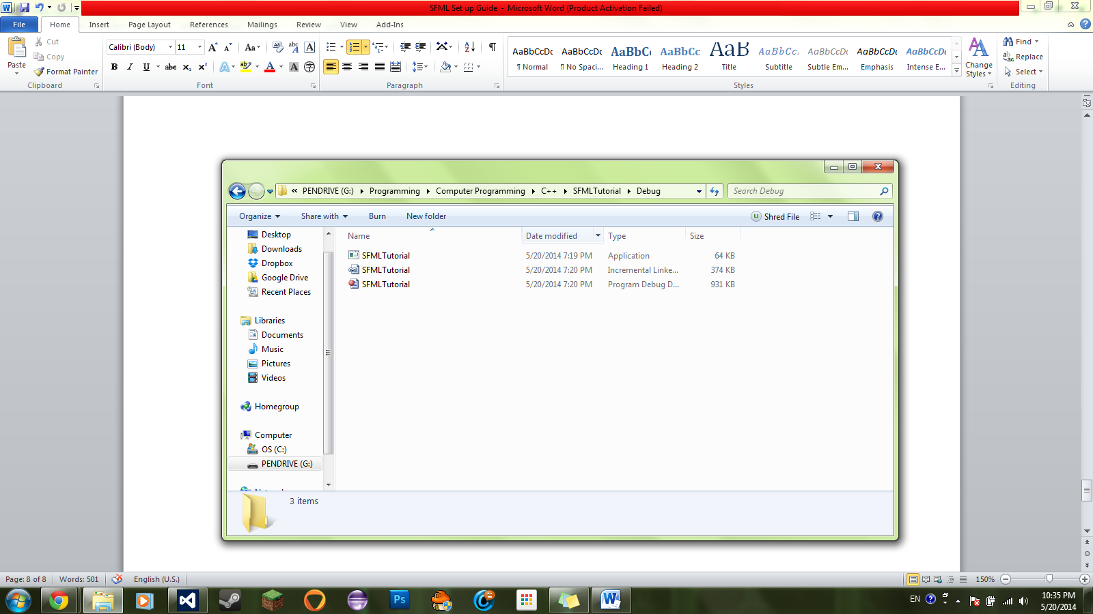
3. **Paste** the .dll files into the folder 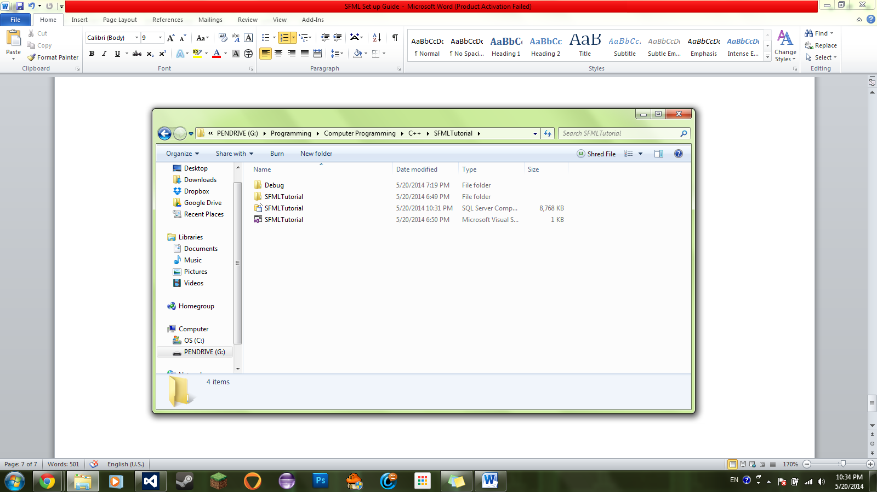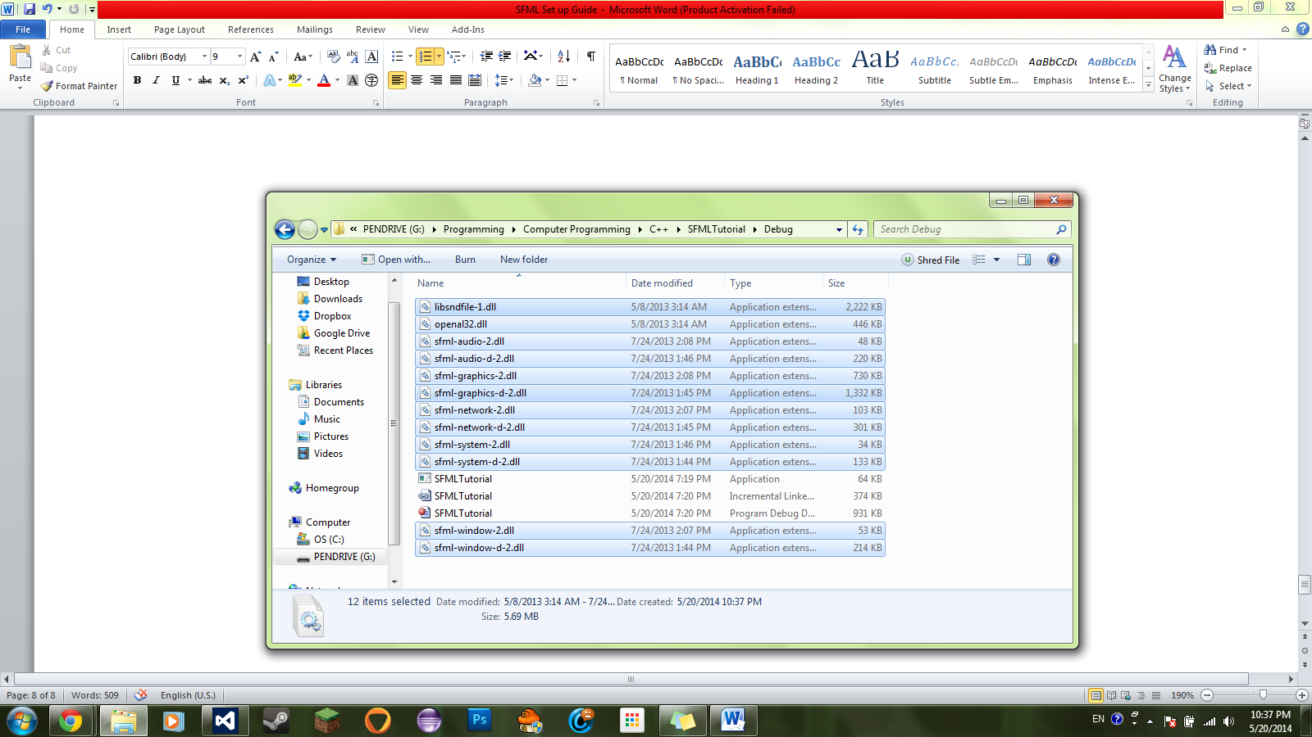
4. Go back into your project in Visual Studio.
5. Run it. At this point, you should be set. Good luck! :D 